Sass is a css pre-compiler tool which allows the use of variables, functions, mixins and more for css.
Precompiled css use the .scss extension.
This will make the work with css much more efficient, faster, DRY.
Compass is built on the top of Sass and has css3 build-in mixins, handy cross browser css helpers and more.
As from now, the css files will be generated only by the precompiled css files (.scss) edited by you. Extra static .css files will NOT be taken in consideration.
This document will guide you through the integration of the Sass into our development environment.

Prerequisites
The following steps must be processed only once, at the first time use.
Ruby must be installed locally in order to use SASS.
Download the latest version here.

Once installed, launch the Ruby Command Prompt:
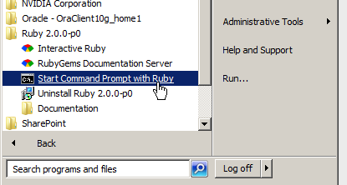
run the following command:

gem install sass

then run the following in order to install compass
gem install compass

open Idea and select Settings > External Tool: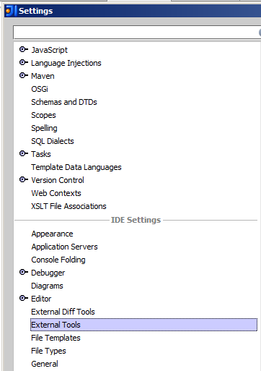
Click the + icon 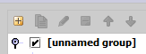
Input “Sass Watch” for the name and “precompile all the scss files” for the description, “$ProjectFileDir$\tools\sassWatch.bat” for the Program (make sure the batch file exists. If not get the latest version) and “$ProjectFileDir$/fe-framework/assets/compass” for the Parameters (make sure that then compass folder exists):
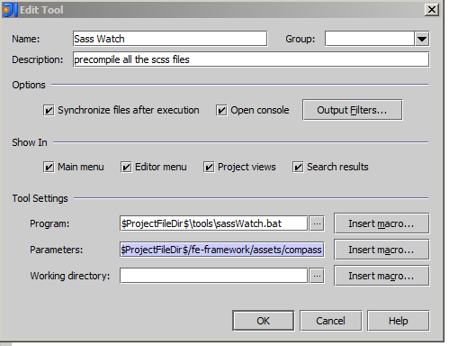
go back to the Settings window and select Keymap. Find Sass Watch in the keymap :
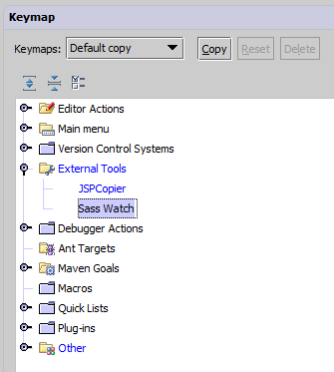
Right-click on Sass Watch and select Add Keyboard Shortcut.
Set <ctrl>+<alt>+W for the shortcut: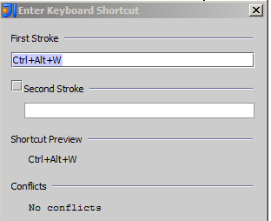

Run the Sass Watch Tool
Before running the Sass Watch Tool, please make sure that the path to the ruby executables is set in your path environment variable.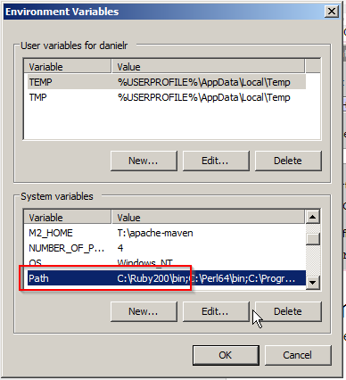
You will need to re-open Idea in order the changes to activate the changes.
When you open the project, run the Sass Watch Tool by using the <Ctrl><Alt>W shortcut.
This will execute the batch file. If everything is ok, you should see the following output in the Run panel in Idea: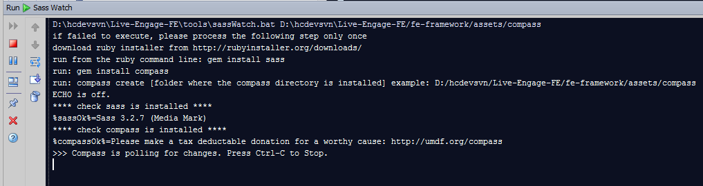

If an error is thrown during the initialization process, close and re-open Idea.
At this stage, Compass is polling for any changes done in the SCSS files contained in the solution.
Everytime a change is done, the app.css file is generated accordingly.
Make sure the changes in the Scss files are VALID! (css + eventually mixins, functions, etc...)
A successful change will be reported like:

If changes are not valid, the processor will throw an error pointing the problematic file and line number:

MAKE SURE THE APP.CSS FILE IS CORRECTLY GENERATED BEFORE COMMITTING YOUR FILES (no errors reported in the log. if an error occurs, the app.css file will be generated with a general error for the content).

Note: Although the css file is intantly updated when a change in the scss file occurs, the change will be reported in the idea within the next minute (cache latency). However, it’s possible to see the change instantly by closing and opening the parent folder...

Working with SASS

- there is no more css folder in the modules asset folder. The only css folder is located in the fe-framework/assets folder.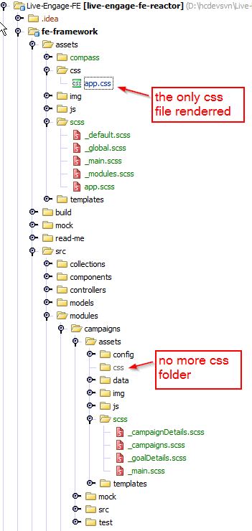

Make sure that you update all the solution (including the app.css file) before committing your files so that the app.css file includes the changes done by the other teams!

- The css folders in the modules are replaced with the scss folder.
- All the sccs files you will use MUST be prefixed with “_”. This means that Compass will NOT generate the corresponding css file. Remember, the only file to be generated is app.css.
However, your scss file will be imported at the parent level so that at the end it will be generated into the app.css file. (see further)
- The root is app.scss which actually imports the “_default” scss (default values like colors, buttons, etc...), “_main” scss which is the LE main css and the “_modules” scss which imports itself all the different modules scss files.
- All your scss files in the different modules must be imported into the _modules.scss file:

@import "../../src/modules/campaigns/assets/scss/_campaigns.scss";

-[UPDATE DANIEL 19.03] you will need to add in the assets/compass/config.rb file your scss folder in the additional_import_paths array. For example, if your scss folder is listed in the myModule module, you will need to add the following:

additional_import_paths = ["../../src/modules/campaigns/assets/scss",
"../../src/modules/myModule/assets/scss"]

Note that making changes in the config.rb file requires to restart the batch file in order the changes to take effect

- The global variables (colors, custom mixins, etc...) are located into the _global.scss file.
Therefore all your scss files should import by default the _global.scss file.
- The default classes (common classes for fonts, buttons, etc...) are located in the _default.scss file.
- For your css3 properties, use the mixins defined in Compass. You can search for example for gradient and use the mixin which best fit your needs.
- For any questions, feel free to ask
Troubleshooting
- the Sass Watch throw an error in Idea
if you had installed ruby while Idea was open, you will need to restart Idea

[Shaul]: Verify that ruby path ‘C:\Ruby200-x64\bin;’ exist in PATH var in Window Environment variables

